SCIENTIFIC NOTE

A LARVAL HOST PLANT OF ARCHAEOSES MAGICOSEMA (MEYRICK, 1936) (LEPIDOPTERA: COSSIDAE)

Garry A. Webb
Technomyrmex Pty Ltd, PO Box 2076, Taren Point, NSW, 2229

Summary
The biology of the cossid moth Archaeoses magicosema (Meyrick) is not well known. There are no known larval host plants for this species but other species of Archaeoses from Western Australia are known to breed in Myoporum spp. (Myoporaceae). This paper documents the emergence of A. magicosema specimens from damaged Hemigenia purpurea (Lamiaceae).

Keywords: Archaeoses magicosema, Hemigenia purpurea, larval host.
INTRODUCTION
Hemigenia purpurea R.Br. (Lamiaceae) is a small spindly shrub restricted to the Sydney and Nowra regions of New South Wales (Anonymous 2026). It is one of a large genus primarily resident in Western Australia (Guerin 2005). Knowledge of the insect associations with Hemigenia are sparse but it appears that native bees are common visitors to flowers of Western Australian species. There does not appear to be any historic records of Hemigenia being larval hosts of any wood-boring insect species.
Archaeoses magicosema (Meyrick) is a small species of Cossidae, for which no larval host plants have been recorded, to my knowledge. The related species Archaeoses polygrapha (Low.) is known to infest branches of Myoporum spp. (Myoporaceae) (Common 1990, Jennings 2001).
In October and November of 2025 several large H. purpurea (ca. 1m in height and ca. 20mm diameter at ground level) in Royal National Park (Sydney, NSW) were observed with internal damage to the root and stem system. Whole plants including the root system were collected and stored.
OBSERVATIONS AND DISCUSSION
Larval host plants
Several larger specimens of H. purpurea (Figure 1) on a sandstone ridge along Wises Track in Royal National Park (RNP) were excavated and showed evidence of infestation of the root system and lower stem (Figures 2 and 3), at the time believed to be caused by a species of Cerambycidae (Coleoptera). A further infested specimen was collected from Curra Moors track (also in RNP). At a later time (January 2026) extrusion of pupal cases, typical of wood-boring moths, was observed and adult moths of A. magicosema emerged from the samples from Wises Track. None emerged in a pristine state and the wing pattern was obscured in some cases. Nevertheless, the pattern on the hind-wing was sufficiently clear on at least one specimen to confirm it as A. magicosema. The specimen from Curra Moors track did not emerge successfully and died in the pupal chamber.
These records represent the first known larval host plants for A. magicosema, to my knowledge.
Archaeosus magicosema records from Hemigenia purpurea
- RNP, Wises Trail, -34.138871, 151.060141, collected on 30 Oct. 2025, emerged 10 Jan. (2 specimens), 16 Feb. 2026 (1 specimen).
- RNP, Curra Moors Trail, -34.150641, 151.072217, collected on 4 Nov. 2025, died during pupation 2 Jan. 2026 (1 specimen).

Acknowledgements
One external reviewer provided useful comments on this manuscript.
REFERENCES

Anonymous (2026) (https://plantnet.rbgsyd.nsw.gov.au/cgi-bin/NSWfl.pl?page=nswfl&lvl=sp&name=Hemigenia~purpurea, Accessed 21 February 2026.

Common I.F.B. (1990). Moths of Australia. Melbourne University Press, 535pp.

Guerin G. (2005). Floral biology of Hemigenia and Microcorys (Lamiaceae). Australian Journal of Botany 53: 147-162.

Jennings C. (2001). Australian Plants Online. Eremophila: The Emu Bush. https://anpsa.org.au/APOL22/jun01-2.html.

Figure 1. Live Hemigenia purpurea on Wises Trail (Royal National Park, Sydney)

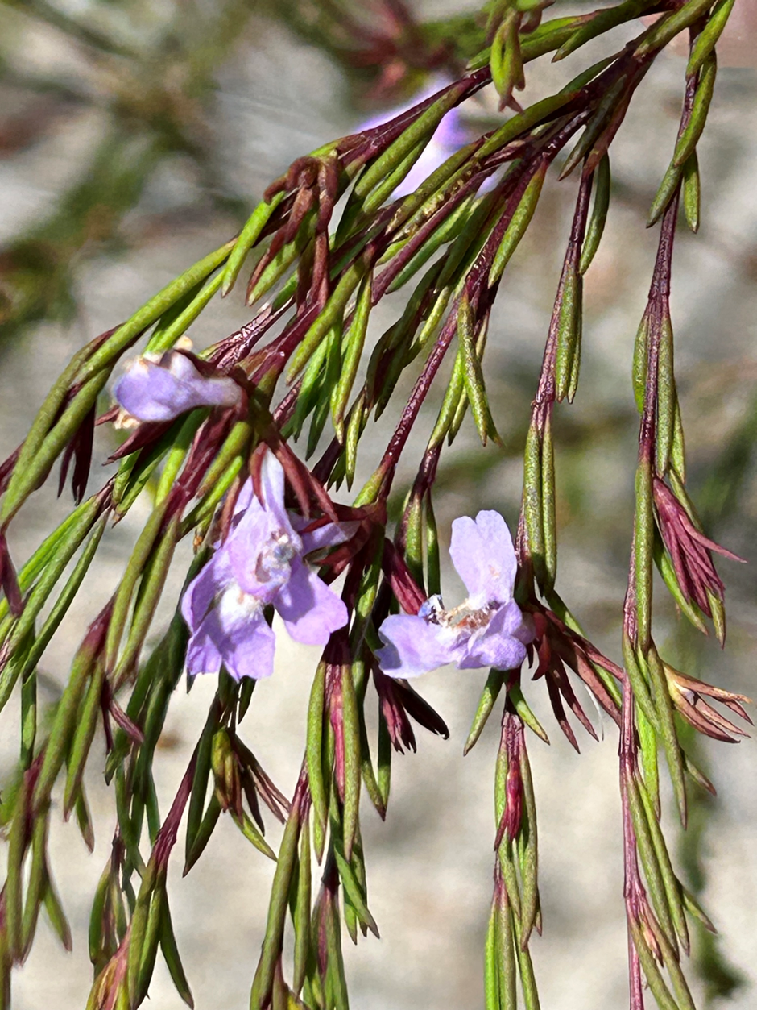

Figure 3. Damaged root system of Hemigenia purpurea | Figure 4. Dissected damaged root and stem system of Hemigenia purpurea
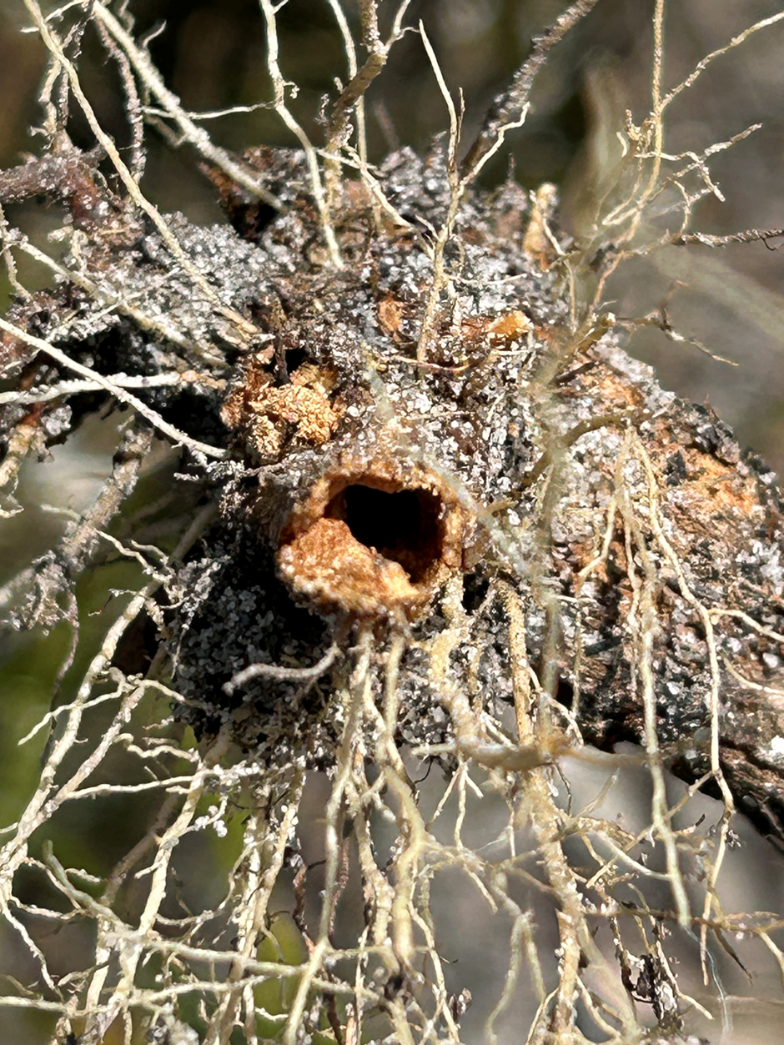 | 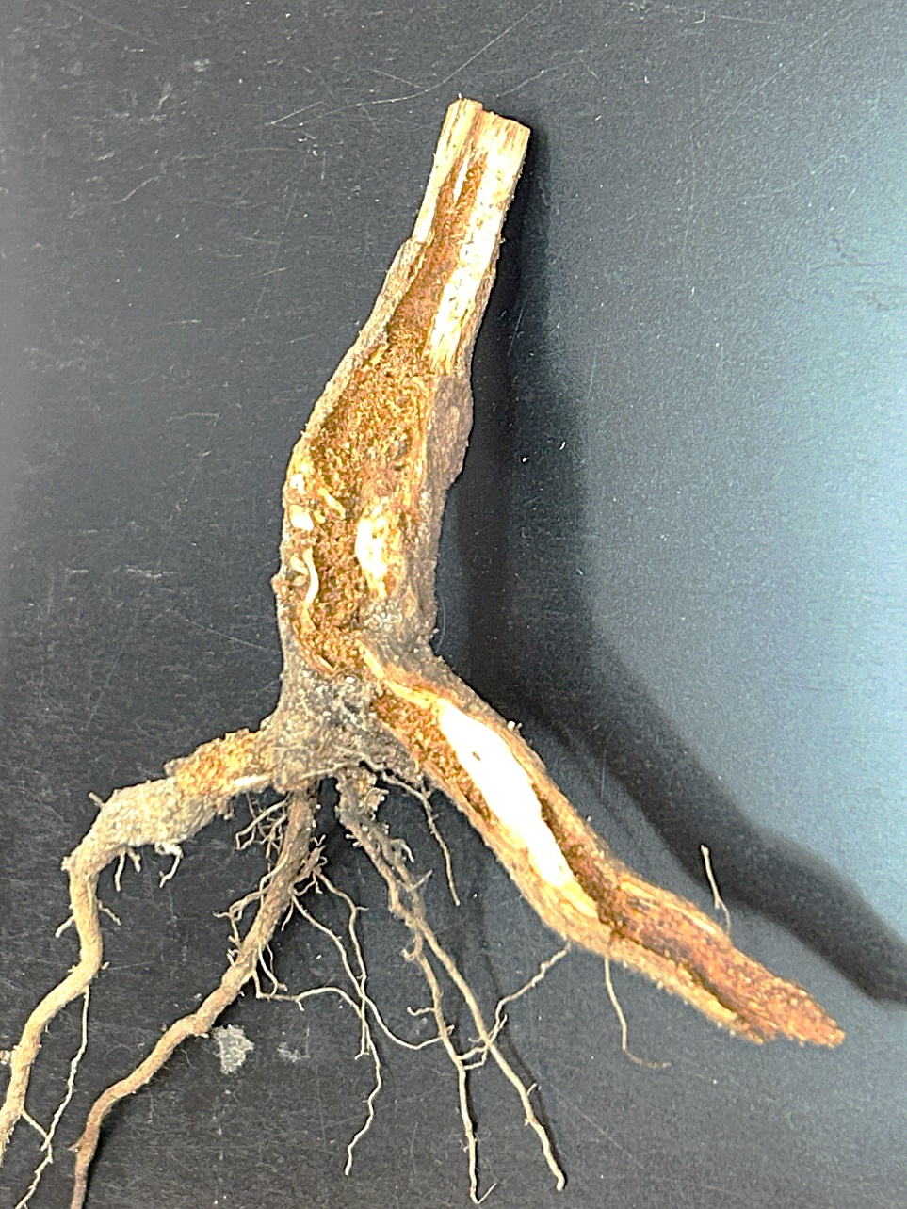
Figure 4: Adult Archaeosus magicosema (photo courtesy of Atlas of Living Australia website at http://www.ala.org.au. Accessed 7 May 2026. Photo credit: dhfischer

